
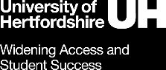
Activity Evaluation Report
Title of activity
School/Schools involved
Description of activity and what took place.
How many students and target learners took part?
Aims of activity
You can populate this section from your evaluation plan.
Evidence to support the activity
You can populate this section from your evaluation plan.
Intended Outcomes

You can populate this section from your evaluation plan.
How did you evaluate?
What tools did you use to collect data? How many learners took part?
Evaluation Findings
Did you achieve your intended outcomes? Were there any unintended outcomes? How did you measure the impact?
You could also add any quotes from learners or teachers if you have them.
Any final thoughts or comments for going forward?

