How to write an essay (UNI Club)

For your final assessment for each UNI Club Module, the University of Northampton would like you to submit a 1,000 word essay, answering your essay question and reflecting upon what you have learnt.
You need to show us what you have learnt during the module, mixed in with what you already knew and your own opinions. These opinions need to be backed up with evidence (sources that you have found that support the point you are trying to make).
We are looking for students to be able to demonstrate that:
- You have learnt something about your topic
- You are able to write 1,000 words about your topic
- You can refer to external sources
- You can critique – i.e. you can demonstrate different opinions
- You can write this in the first or third person

It is important to plan your essay before you start writing.
An essay has a clear structure with an introduction, paragraphs with evidence and a conclusion.

Planning
It is important to plan before you start writing an essay.
The essay question or title should provide a clear focus for your plan. Exploring this will help you make decisions about what points are relevant to the essay. What are you being asked to consider?
Organise your thoughts. Researching, mind mapping and making notes will help sort and prioritise your ideas.

Introduction
An introduction should focus directly on the essay title and aim to present your main idea, in your answer.
For example, if the essay title is: “Discuss the different roles that Dumbledore portrays in the book, Harry Potter and the Philosophers Stone.”
Your opening statement might be:
“Dumbledore portrays many roles in the book, Harry Potter and the Philosophers Stone. In the following paragraphs, I will evidence his role as teacher, parent/carer and rebel demonstrated through his words, actions and behaviour in the book.”
The statement gives a clear answer to the essay question. The rest of your essay could justify that answer by looking at all the different ways that he seems to represent authority, and the impact that has at different points in the story.
An introduction briefly introduces your main ideas and arguments - and the rest of the essay will explore this in greater detail.

Using evidence and referencing
Evidence is the foundation of an effective essay and provides proof for your points.
Back up each of your statements with evidence. The evidence should be relevant and clearly connected to the point you’re making. As well as using what you learnt in the e-module, you are required to use at least two other sources of information. You can refer to your e-module videos, PowerPoints and workbooks.
Sources can be:
- YouTube videos
- Articles in magazines
- Websites
- Books
Referencing is a way of acknowledging other peoples’ ideas and work. You do this through a citation (in the text of your work, for example, after you discuss an idea that you got from a source) and a reference list at the end of your work.

How do I acknowledge / reference my sources?
There are different ways to reference, and for the UNI Club, we would like you to reference in the following way:
In the main text of your essay:
If you are discussing something you learnt in a book or magazine, you write the author, the year it was written and page number that has the idea that you’re discussing. This is put in brackets next to your text.
(Rowling, J.K.,1998, p.107).

If it is a website, you write the author of the website, name of the article/page you are referencing, and year the webpage was updated (it usually states the date of creation at the bottom of a webpage).
(BBC website, How to write an essay, 2021)

At the end of the essay, write all of your references in alphabetical order as a full list of ‘references’. The titles are usually highlighted in bold. Therefore, your list of references might look like this:

References:
BBC (2021) How to write an essay. https://www.bbc.co.uk/bitesize/topics/zv7fqp3/articles/znvn92p [Accessed: 14/9/21]
Rowling, J.K. (1998) Harry Potter and the Philosophers Stone. Scholastic
UNI Club e-module notes: History is all around [accessed June & July 2021]

For the UNI Club, we are not looking for ‘perfect’ references. We would just like to see that you have used new sources (outside of your e-module) and that you are able to acknowledge your sources. If you pretend that someone else’s writing is your own, this is called plagiarism, and is a very serious offence in further and higher education. It is not acceptable to pretend someone else’s work is your own. However, if you evidence and reference any sources you use, this is acceptable when writing an essay.

Paragraph structure
Think about how you are going to organise each paragraph.
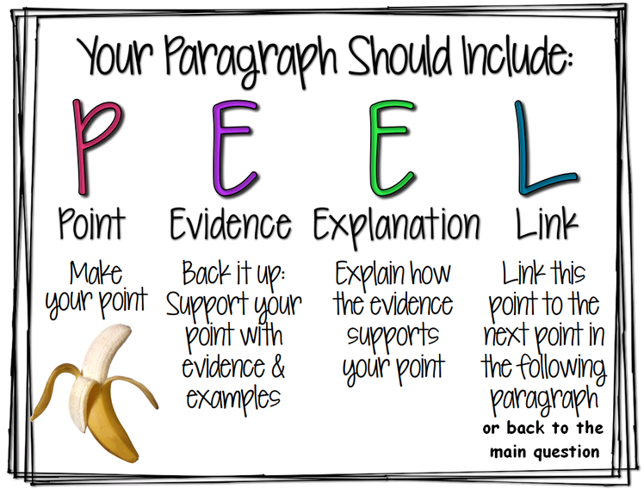
Source: https://www.virtuallibrary.info/peel-paragraph-writing.html. Accessed 14/9/21 2021
Try watching this video clip which explains it more!
You might want to start with a topic sentence that summarises the main point of the paragraph. This sentence acts like a mini introduction for this paragraph of the essay.
The rest of the paragraph should then develop this main point by providing more explanation, detail and evidence.
When planning your essay, you may find it helpful to have your main points on notes or in a mind map.

Conclusion
A conclusion is the final paragraph of your essay. It should tie all the loose ends of your argument together.
An effective conclusion may:
- restate your main idea
- directly link back to the essay title or question
- briefly summarise the key supporting points
- give readers something to remember - a final thoughtful idea or reflection
It’s useful to show the reader that you have reached your conclusion by using words or phrases such as:
- In conclusion
- To conclude
- Finally
- In summary
- Remember
Thinking about what to include in an essay first will make it easier to structure and write the essay. Your essay will be much more convincing if you can offer evidence for each of your ideas.

You may also want to have a look at this link on the BBC: How to write an essay.
BBC (2021) How to write an essay. https://www.bbc.co.uk/bitesize/topics/zv7fqp3/articles/znvn92p [Accessed: 14/9/21 ]

Submission
Good luck with your essay writing! The deadline for submission is:
- Monday 13th December 2021
- Monday 28th March 2022, or
- Monday 27th June 2022
You are required to write your name, school, e-module and name of your essay on the front page of your essay.
Don’t forget to name your document with your name and school name too!
Please submit your essay to: schoolsengagement@northampton.ac.uk

