Black History is Northamptonshire’s History:
Module Booklet

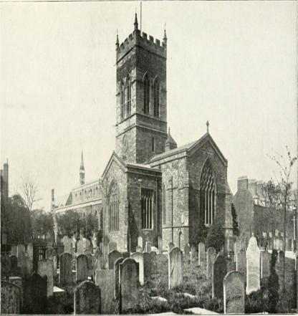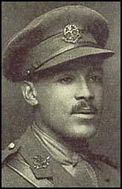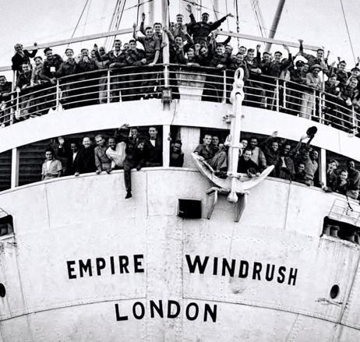

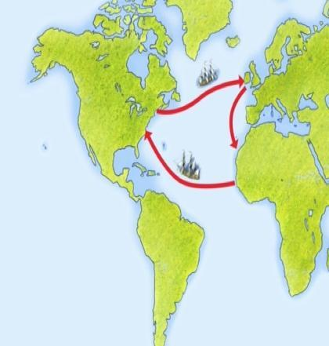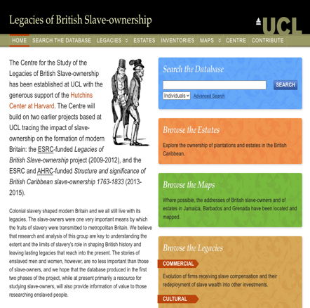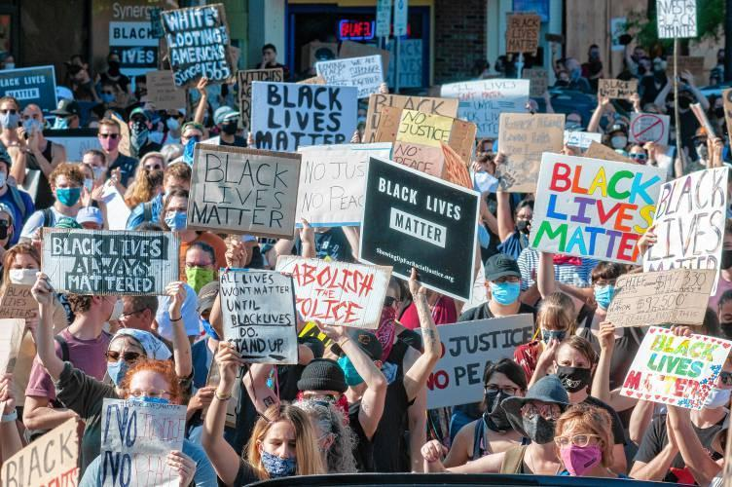

What are the different types of History?

Learning Objectives for the module:

- To gain knowledge and understanding of the historical development of Northamptonshire
- To gain an understanding of a wider cultural heritage that needs to be explored
- To promote an understanding of events not part of the wider curriculum
- To support students to develop skills in investigating, researching, analysis and evaluating sources

What do you understand about the word ‘history’?
Write three examples of different types of history here.
You can draw them instead if you want to.

Lesson 1: An introduction to the Slave Trade and its links to Northampton

Activity 1: Watch the video and write down at least two things you have learnt from the video.
https://youtu.be/7xdd8DvhF8k

Activity 2: What do you think about Slave traders living in Northamptonshire? Write down your thoughts. Discuss them with another student if you are working together.

Activity 3: Click on the database link that takes you to the front page. In the ‘Search the Database’ box, type in Northamptonshire, and in the drop-down menu, click addresses. This will allow you to search the database the same way as I did.
https://www.ucl.ac.uk/lbs/

If you want to, you can search for individual people, or places.
Have a look, and write down what you discover here:

Homework for Lesson 1:

Watch the video and write down 4-6 new things you learnt from this lesson.

https://www.bbc.co.uk/teach/class-clips-video/history-ks3-ks4-britains-forgotten-slave-owners-1830-slavery/z4f76v4

1.

2.

3.

4.

5.

6.

Lesson 2: Northampton’s Hero, Walter Tull

Activity 1: what did you learn from lesson 1, write down 3-5 things here:

Activity 2: Watch the video clip and write down the ways in which life was difficult for Walter Tull. https://youtu.be/XxfXb2A0TdY

Think about:
- His daily life
- Life as a footballer
- Life as a soldier

Lesson 2: Northampton’s Hero, Walter Tull

Activity 3: Picture Search! Can you find out where these pictures were taken? Use the internet to track down Walter Tull…

Activity 4: Write down 3 reasons why Walter Tull should be awarded the Military Cross:

Lesson 2: Northampton’s Hero, Walter Tull - Homework

Watch the clip from the Black Heroes Foundation and write/draw your hero (there are additional resources at the end of this booklet to help you).
https://waltertull.org/
https://youtu.be/7ragWmz3ypc

Lesson Three: The Windrush Generation

Activity 1: Reflect on lesson 2 – what did you learn?
Write your thoughts here:

Activity 2: Answer the following questions after watching the video clip.
https://youtu.be/qKJ-iqFmHOQ

- Who were the Windrush Generation?

- Where did they come from?

- In 1948, all Commonwealth Citizens were British Citizens – TRUE/FALSE

- How many people arrived on the Empire Windrush in 1948?
    - 100
    - 257
    - 492
    - 568

- The 1971 Immigration Act gave Commonwealth citizens the right to stay in Britain. What did the Home Office not do? Write down 1 problem:

- What happened under the ‘hostile environment’?

Activity 3: How did the news at the time prevent the people coming from abroad?

In this booklet, you will find scripts from the BBC Home Service news for 22nd June 1948.

Read through the news scripts in your booklet.

- Does the script give you the full story of the arrivals?
- Does the script change at all? Why might that be? Think about why this happened, how might the audiences have reacted to each one?

Scripts:

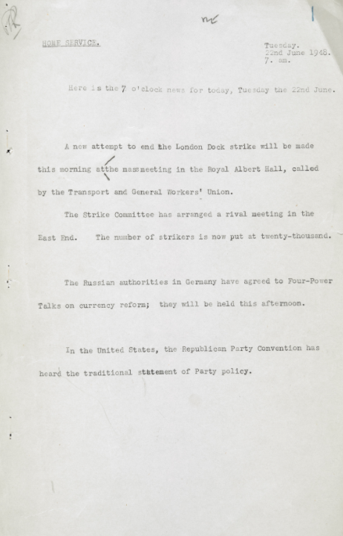

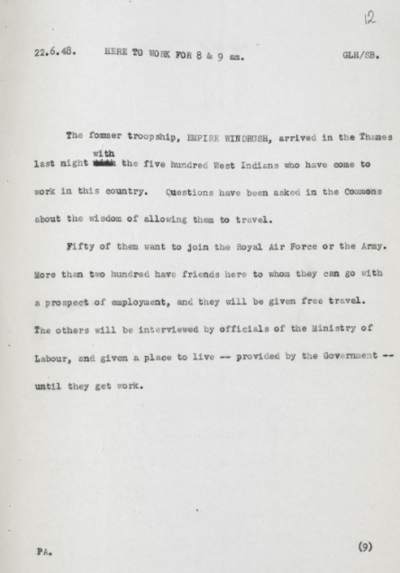

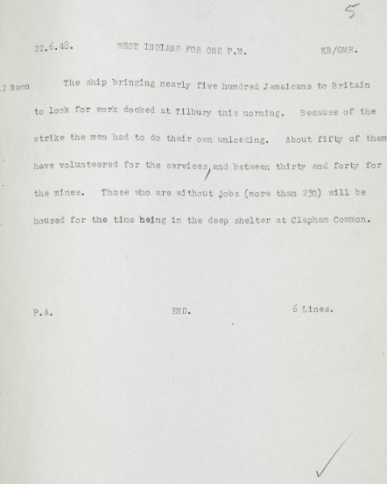

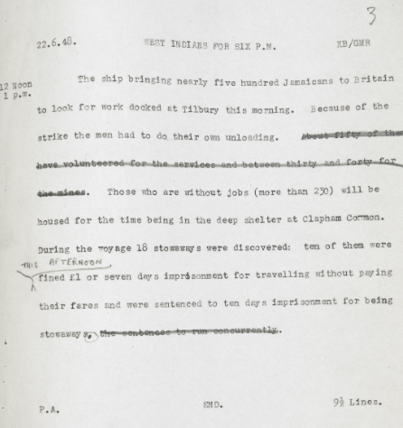

Lesson Three: The Windrush Generation: Homework

You are a reporter for a newspaper in June 1948.
Write a series of Facebook posts that might have appeared in the news about the new arrivals on the Empire Windrush.
Are you going to present one point of view, or a balanced point of view?

Lesson four: Power and Protest –
The Black Lives Matter Campaign

Activity 1: Reflect on lesson 3 – what did you learn?
Write down 3 things:

Activity 2: What is the Black Lives Matter Campaign?
https://youtu.be/4Vl4I0weXPU
Watch the clip and design your own placard/banner here:

Activity 3: Read through the news snippets from around Northamptonshire about the BLM protests.
- How are they presented?
- One sided?
- Balanced view?

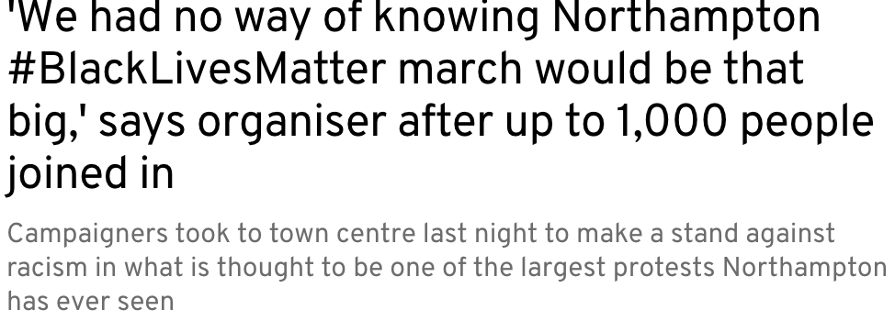

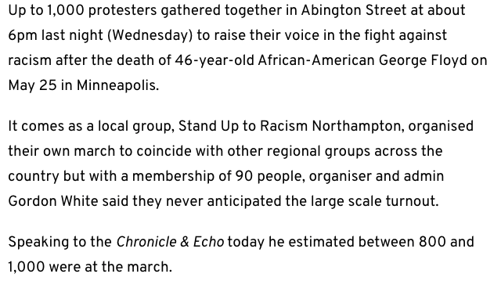

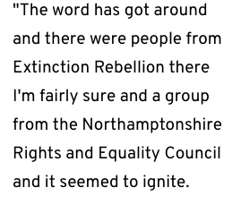

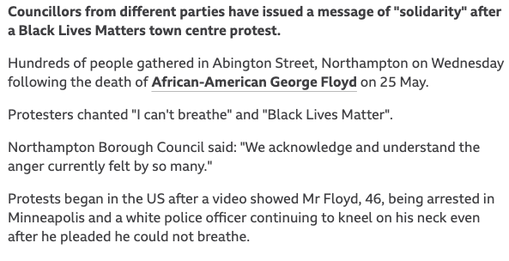

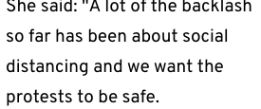

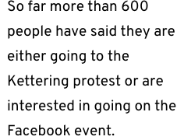

Final activity:

Create a poster celebrating black history in Northamptonshire and beyond using all of the resources provided in the lessons.

Planning space:

Extra resources to help you:

https://blackhistoryintwominutes.com/

https://www.bbc.co.uk/teach/black-lives-black-history-resources/zy7sm39

https://waltertull.org/walter-tull-videos/

https://www.blackheroesfoundation.org/?gclid=CjwKCAjwjbCDBhAwEiwAiudBy8hcLtZLY8CtwTcEpBUtCmKxoMCd0H3pfDSenyL6P6qKwnbpDp1mahoCvSsQAvD_BwE

https://www.blackheroesfoundation.org/black-heroes-in-history/

Sources – how to decode a source

- WHO – Who produced the source?

- WHERE – Where was it produced?

- WHEN – When was it produced?

- WHAT – What type of source is it?

- WHY – Why was it produced?

- HOW – How does it help our understanding of the past?

